**REACT**

**#3**

**Created a React Application “eventexamplesapp” to handle various events of the form elements in HTML.**

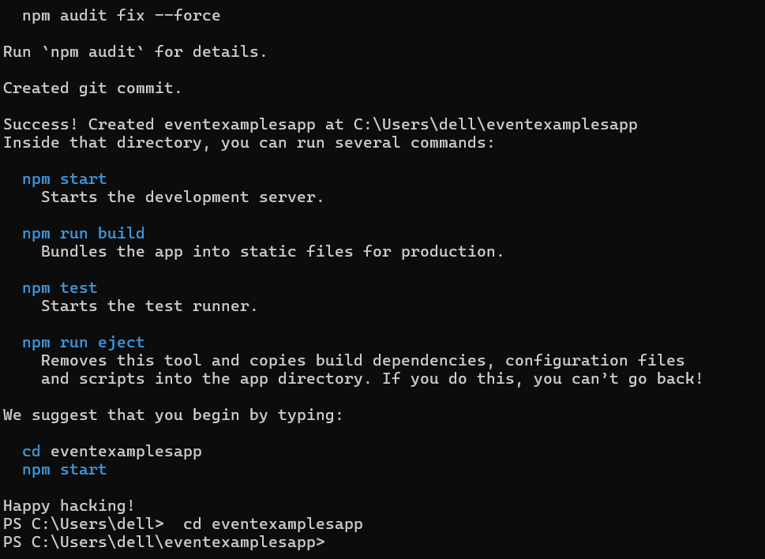

1. **Created “Increment” button to increase the value of the counter and “Decrement” button to decrease the value of the counter. The “Increase” button should invoke multiple methods.** 
   1. **To increment the value**
   2. **Say Hello followed by a static message.**
2. **Created a button “Say Welcome” which invokes the function which takes “welcome” as an argument.**
3. **Created a button which invokes synthetic event “OnPress” which display “I was clicked”**

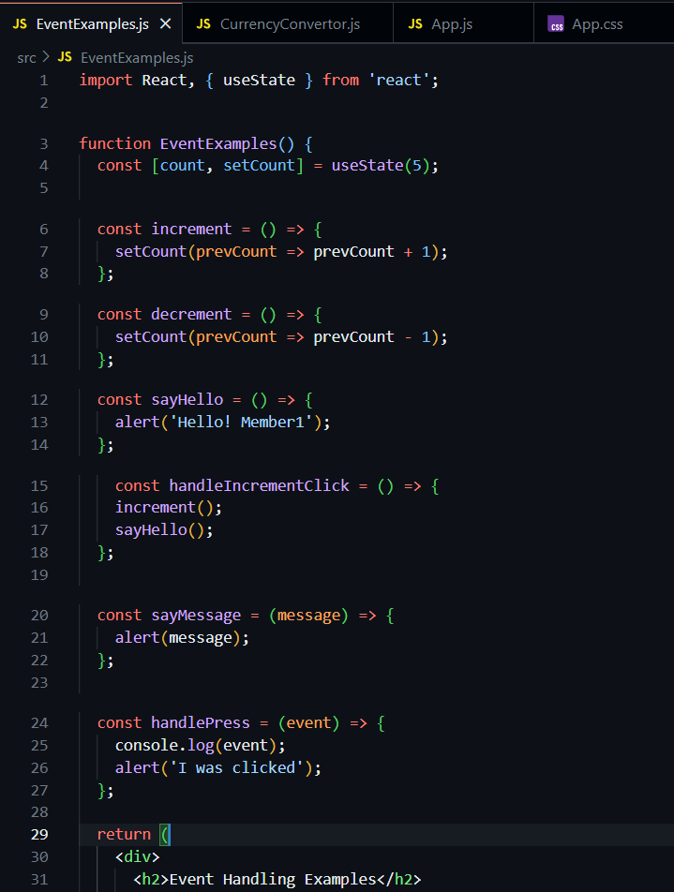

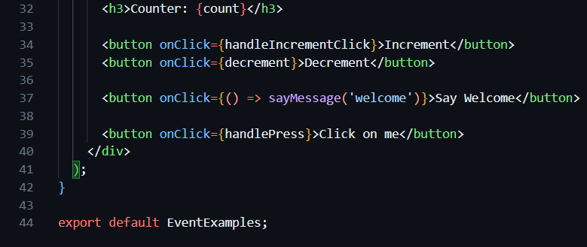

**OUTPUT –**

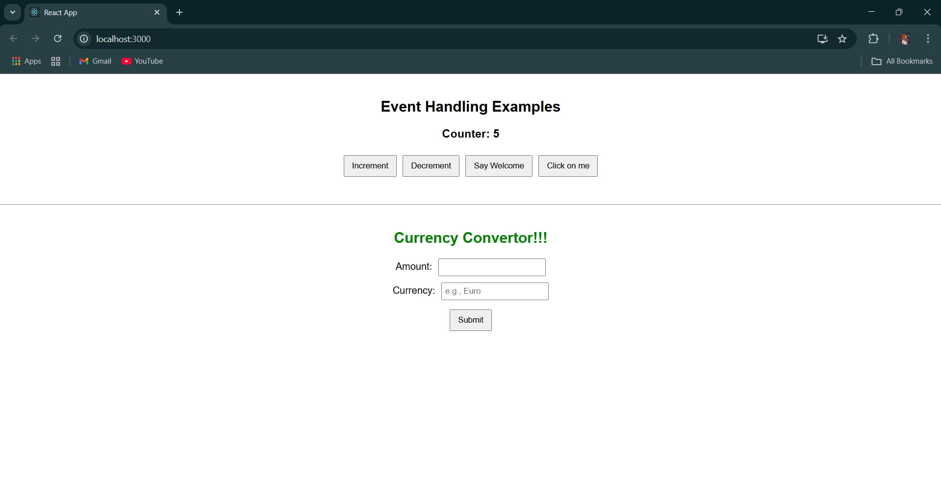 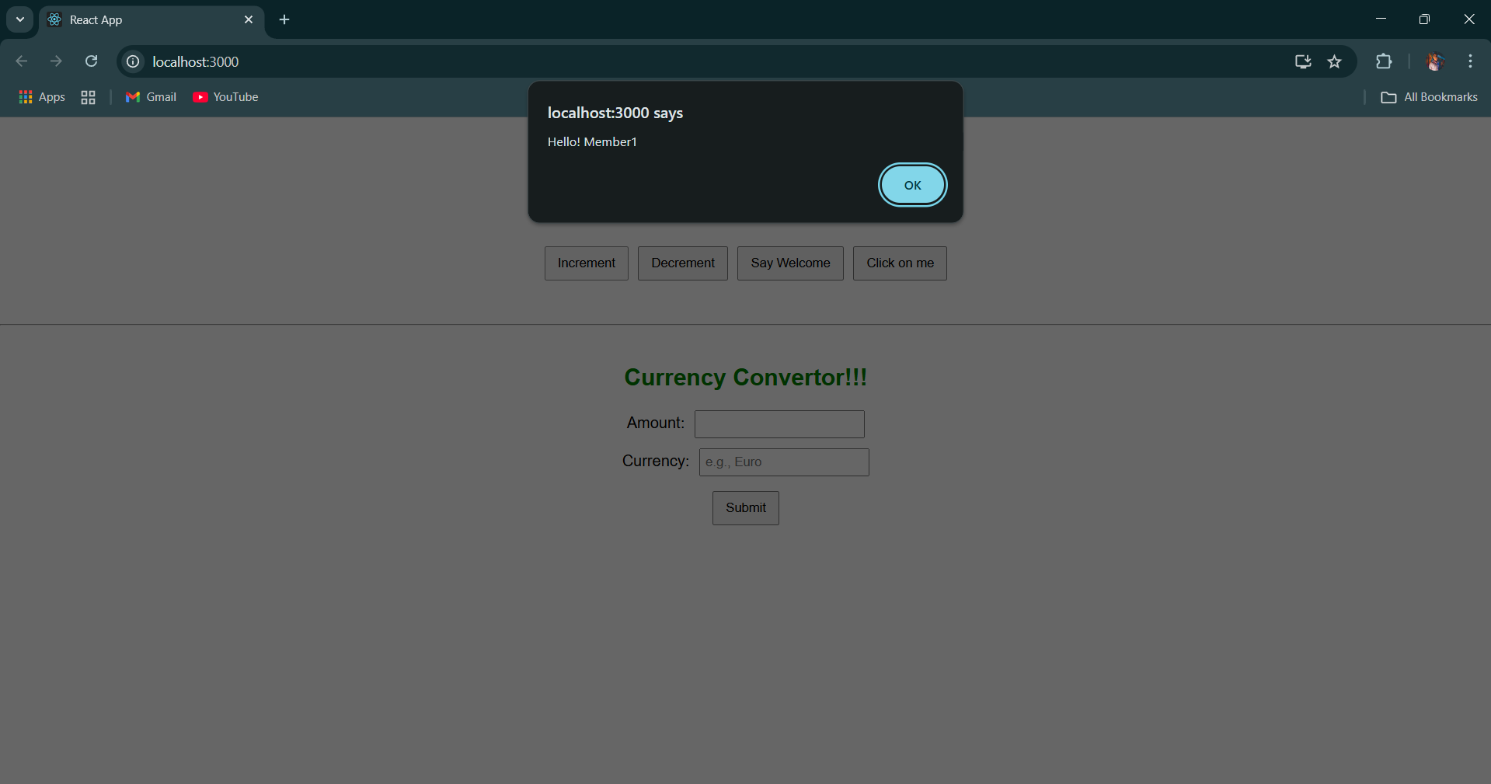 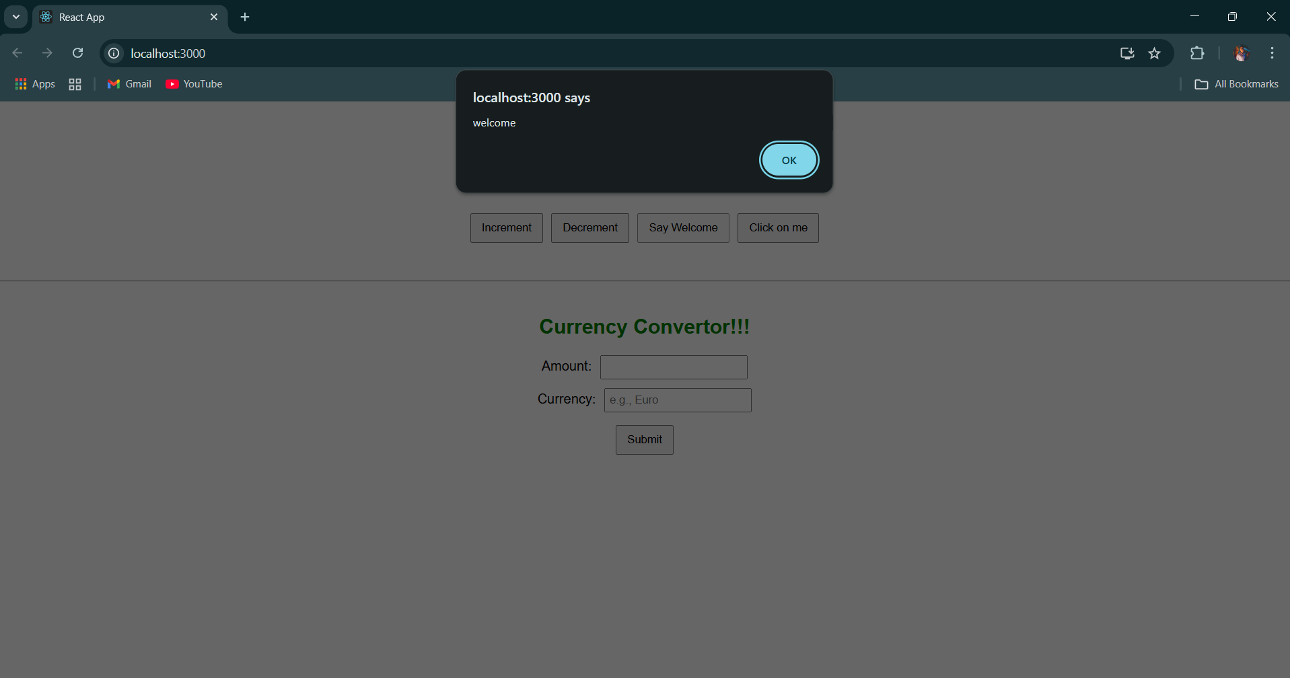 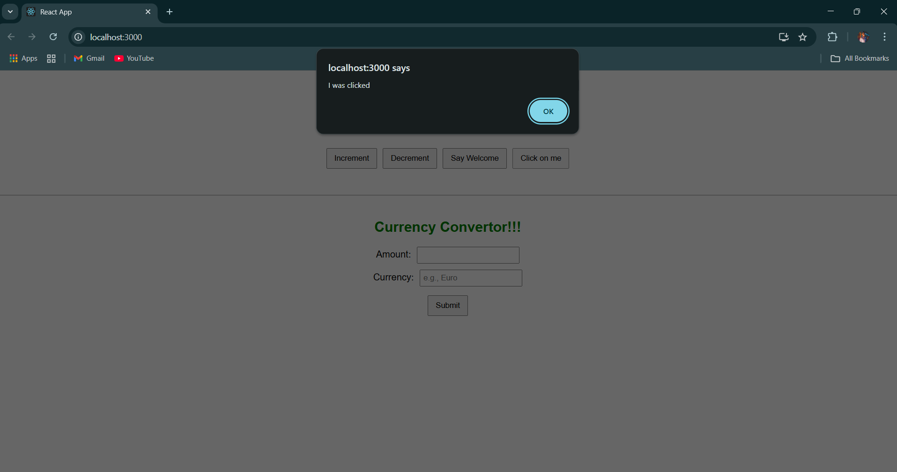

**Created a “CurrencyConvertor” component which will convert the Indian Rupees to Euro when the Convert button is clicked.**

**Handle the Click event of the button to invoke the handleSubmit event and handle the conversion of the euro to rupees.**

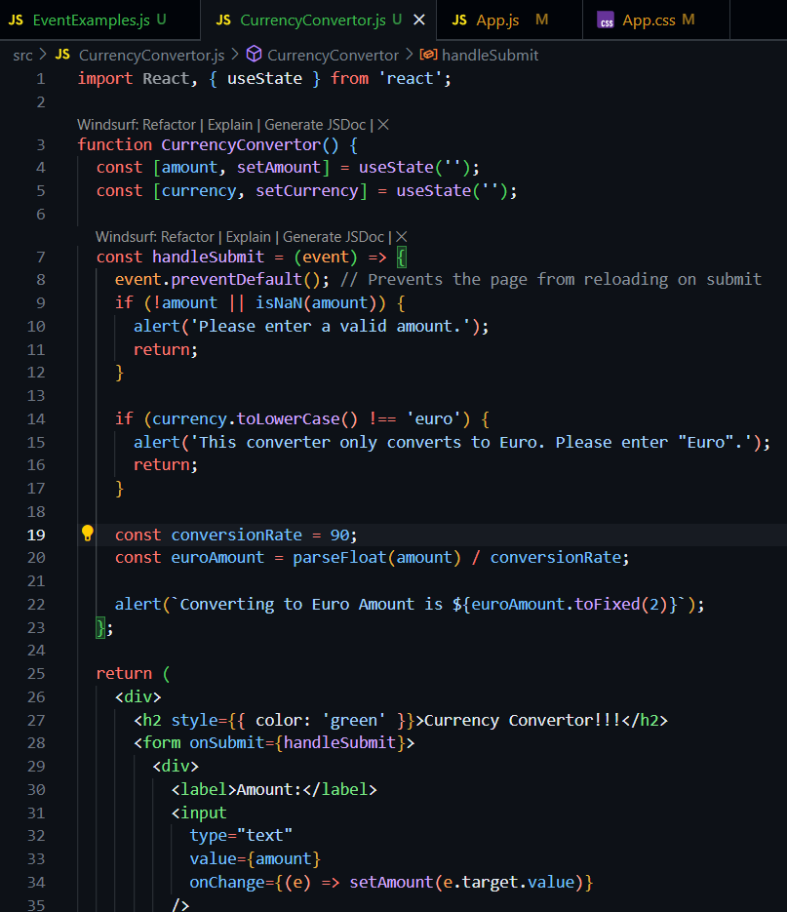

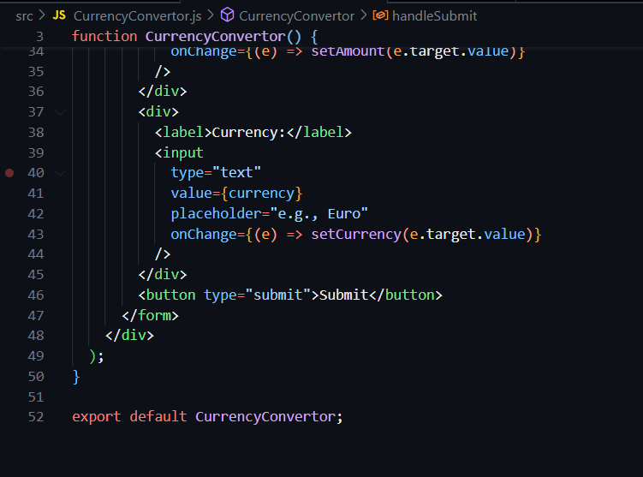

**OUTPUT -**

